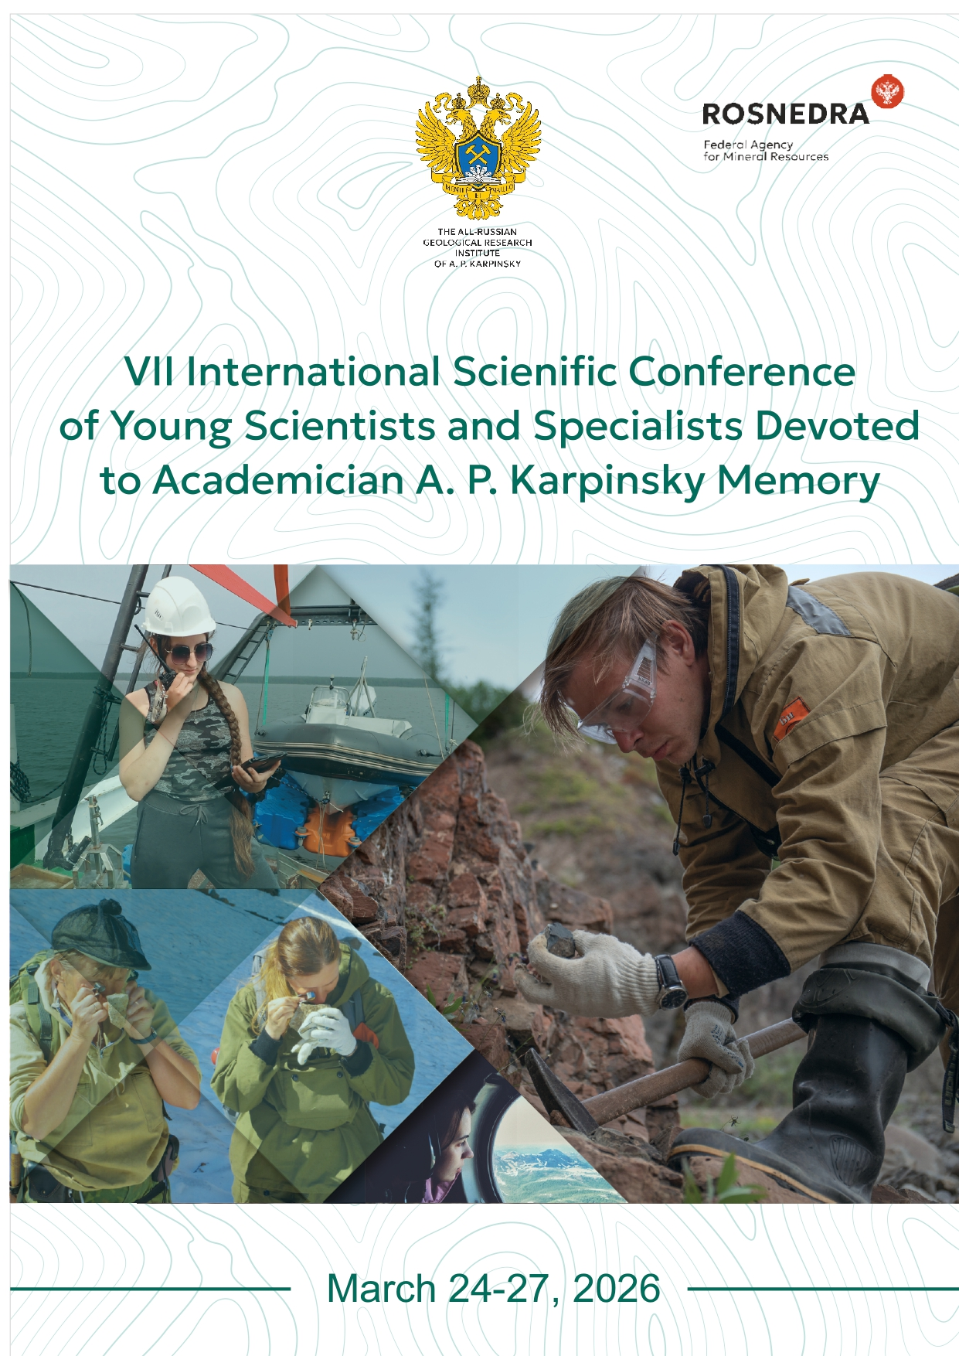

CONFERENCE ORGANIZERS

◆ Federal Agency for Mineral Resources - Rosnedra
◆ The All-Russian Geological Research Institute of A.P. Karpinsky

PURPOSE AND OBJECTIVES OF THE CONFERENCE

The conference is aimed at bringing together young scientists and specialists in the field of geology, exchanging scientific and practical information, and discussing topical issues related to modern approaches to the development of regional geological exploration of mineral resources, as well as the search and exploration of minerals.
The conference accepts papers on current and emerging scientific directions, as well as groundbreaking technologies in the field of regional geological exploration of mineral resources.

CONFERENCE TOPICS
◆ Regional Geology
◆ Stratigraphy and Paleontology
◆ Quaternary Geology
◆ Petrography
◆ Tectonics
◆ Mineralogy
◆ Metallogeny
◆ Geochemistry
◆ Geophysics
◆ Oil and Gas Geology
◆ Hydrogeology and Groundwater
◆ Marine Geology and Geoecology
◆ Geology and Mineral Resources of Arctic Basins
◆ Geographic Information Technologies, Import Substitution, and Artificial Intelligence
◆ Remote Sensing Methods

CONFERENCE FORMAT

The conference will feature oral presentations only. The Organizing Committee reserves the right to select papers for oral presentations. Oral presentations will be 15 minutes in length, with an additional 5 minutes for questions and discussion. Presentations will be grouped into thematic sections. Each participant may deliver no more than one oral presentation, but may co-author other presentations.

During the conference, workshops/seminars featuring leading specialists and tours of the Karpinsky Institute will be organized.

Authors of the best presentations will be awarded diplomas and commemorative gifts, along with the opportunity for a complimentary internship at the Karpinsky Institute.

CONFERENCE ABSTRACTS COLLECTION

Following the event, an electronic collection of conference abstracts will be prepared. Materials submitted to the conference will be published in electronic format.

For publication of materials, speakers must send their abstracts to the Organizing Committee at geolconf@karpinskyinstitute.ru. The Organizing Committee reserves the right to reject abstracts that do not align with the conference's scope and standards.

Upon recommendation from the Conference Organizing Committee, the best papers may be published in the journal "Regional Geology and Metallogeny," which is included in the list of journals recommended by the Higher Attestation Commission of the Russian Federation (VAK RF). Submission of publications to the journal must comply with the rules for preparing articles for print.

REGISTRATION

Registration for Conference participants will be conducted on the conference page of the Karpinsky Institute website at the following link: https://www.karpinskyinstitute.ru/ru/conf/events/index.php?ELEMENT_ID=103412

Registration Deadline: February 16, 2026
Abstract Submission Deadline: March 2, 2026

There is no participation fee for the Conference.

Should you require a visa for the Russian Federation, an official invitation letter will be issued.

ACCOMMODATION

Participants are responsible for arranging and booking their own accommodation.

CONTACT INFORMATION

Kseniia Lukmanova, Leading specialist of the Department of External Scientific and Technical Relations
Kseniya_Lukmanova@karpinskyinstitute.ru

+7 812 328 9090 (еxtension number: 2546)
+7 921 957 59 99

